Kubernetes Task

Step 1:
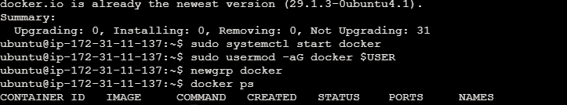

Step 2:
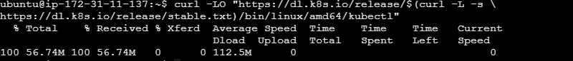

Step 3:
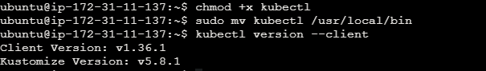

Step 4:

Step 5:
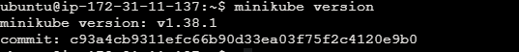

Step 6:
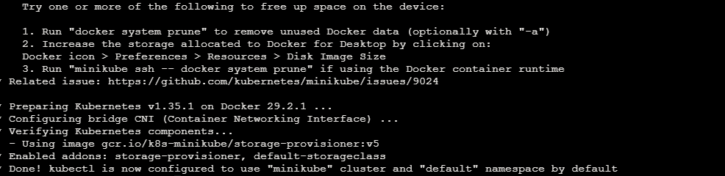

Step 7:

Step 8:
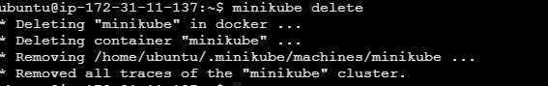

Step 7:
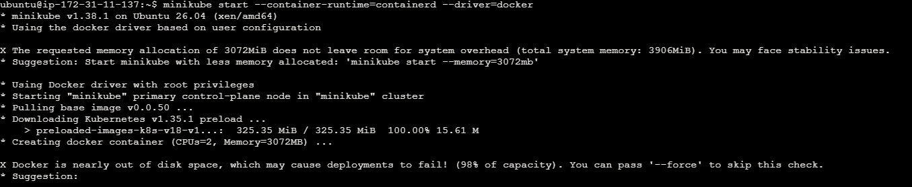

Step 8:

Step 9:
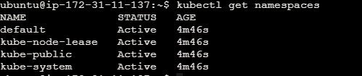
Step 10:
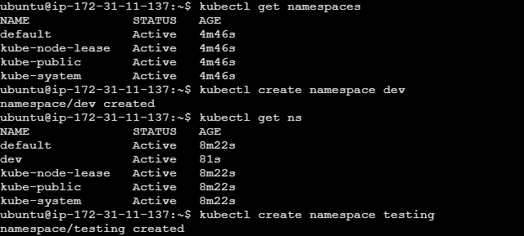

Step 11:
